**:** Creating an Adhoc Network

**Components:** Wireless Router, PC

**Theory:** Ad hoc networks are mostly wireless local area networks (LANs). The devices communicate with each other directly instead of relying on a base station or access points as in wireless LANs for data transfer co-ordination. Each device participates in routing activity, by determining the route using the routing algorithm and forwarding data to other devices via this route.

**Cisco Packet Tracer Setup:-**

**Implementation: -**

**Step1:** Arrange all components i.e., Wireless Router and PC’s

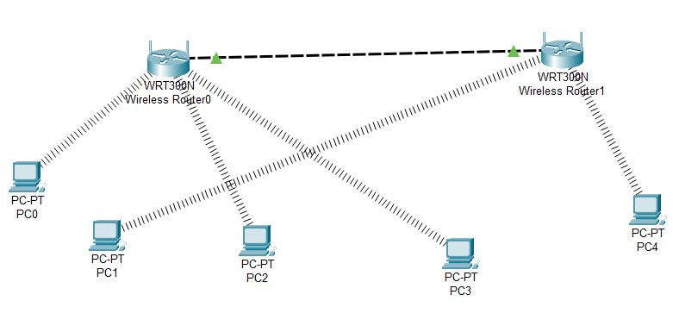

**Step 2:** Configure wireless routers and connect both of them to each other using Ethernet ports:

In **Router0**, go to GUI > Wireless > basic wireless settings

Network SSID: CS and set SSID broadcast to enabled

Now, click on wireless security,

Security Mode: WPA2 Personal, Passphrase: ciscorouter1

Go to the bottom and save settings

In **Router1**, go to GUI > Wireless > basic wireless settings

Network SSID: IT and set SSID broadcast to enabled

Now, click on wireless security,

Security Mode: WPA Personal, Passphrase: ciscorouter2

**Step 3:** Connect all machines/devices (PC’s) to respective router as per our requirements.

Change the Port of all pc’s with wireless adapter

Configure Wireless connection: Click on PC0 > Desktop > PC Wireless

Click on Connect tab > click on refresh > Select CS/IT > Enter Password and connect

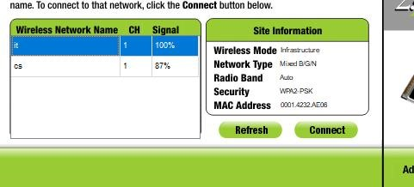

Do similar configuration to all respective PC’s

**Output:**

